INTRODUCTION
Project Context
The automotive services industry constitutes one of the more stable sectors of the Philippine economy, particularly in provincial and rural areas where vehicle ownership continues to expand and car owners depend substantially on local establishments for both mechanical repair and insurance-related needs. Vehicle sales in the country reached a record high in 2025, surpassing the figures of the preceding year (M. Zapanta, 2026). Businesses operating within the field do not always conform to a single service category. Some enterprises, such as TG Customworks, function simultaneously as repair facilities and insurance brokerages, managing services that range from repainting damaged vehicle panels to processing comprehensive car insurance policies for bank-financed vehicles.
Travis Grayson Customize Autopainting and Repair Shop, commonly known as TG Customworks, is located at 49 Villa Tierra St., San Roque, Pandi, Bulacan and has been in operation since 2016 under the ownership of Mr. Gerald Peterson Carpio. Alongside its repair and paint services, the business operates Basic Car Insurance Services, an insurance brokerage accredited under PhilBritish Insurance. PhilBritish Insurance, formerly known as Philippine British Assurance Company, Inc., is a non-life insurance company established in 1960 and headquartered in Makati City, offering motor car, fire, personal accident, marine, and liability coverages nationwide. TG Customworks has been one of its accredited repair shops since 2024, and Basic Car Insurance Services operates as its broker agency in Pandi, Bulacan, facilitating insurance transactions and coordinating claims between policyholders and the provider. The business is run by eight personnel, the owner Gerald Peterson Carpio, Vice President Bettina Jacinto, Internal Vice President Jean Paolo De Guzman who oversees daily records and payments, Maribel Ureta who serves as secretary of TG Group of Companies and manages the insurance database remotely from Hong Kong, mechanic Angelo Alcañices who handles vehicle inspections, three head painters, and a secretary. On average, the business handles 20 to 25 clients every month across both services. At present, all client records, insurance policies, payment transactions, and repair job details are maintained in a combination of handwritten receipt books, physical inspection forms, and multiple Excel files, each handled by a different person. Based on the interview conducted with Internal Vice President Jean Paolo De Guzman on March 2, 2026, the absence of a single integrated system has made it increasingly difficult to keep up with operations as the client base continues to grow. The problems at TG Customworks are not abstract. They show up every time a staff member needs to pull up a client record and ends up spending an hour going through separate files, or when a vehicle comes in for insurance-related repair and nobody can immediately confirm where the claim stands. On the insurance side, checking whether a vehicle qualifies for coverage under the 10-year eligibility rule is done by hand, and the premium computation is performed using a separate computation sheet provided by PhilBritish, with the results manually copied into other files. When a client opts for installment payment, the outstanding balance is noted at the bottom of a handwritten acknowledgement receipt, with nothing in place to flag the account when a payment is missed, leaving the policy at risk of cancellation. On the renewal side, two months before each renewal cycle, PhilBritish Insurance generates a document called the List of Policies Due for Renewal and sends it to the office. The file contains all policies expiring in the following month. Once it arrives, Gerald goes through each entry one by one, messaging each client individually through Facebook Messenger to notify them of their upcoming renewal. There is no system in place to record which clients have already been contacted, which have confirmed their intent to renew, and which have yet to respond, so every renewal cycle is managed from scratch. On the repair side, when a client brings in a vehicle, Angelo, the main mechanic, fills out a physical External Car Condition Checklist covering 14 exterior areas to document any existing damage before work begins. A quotation is then prepared separately using a PDF template typed on a computer, but because that quotation is not connected to the official receipt, the same information has to be encoded again when the client pays, which opens the door to pricing errors. The status of each repair job, whether it is a quick per-panel job that takes one to two days or a full wash-over repaint that can stretch past a month, is updated on paper by Jean Paolo or Angelo. According to Angelo Alcañices, during the same interview, documents have gone missing before, and when asked what the biggest daily struggle is, the answer was simple: tracking.
Many researchers and developers have already tried to solve parts of what TG Customworks is dealing with, and their work is worth looking at, not just for what they accomplished, but for what they openly admitted they could not do. Kawade et al. (2023) built a web-based system for an automobile service centre that covered repair estimates, vehicle service history, job status tracking, and invoice generation. It worked well for what it was designed for, but the researchers themselves acknowledged that insurance processing, claims management, and any kind of brokerage computation were never part of the picture. Their recommendation for future work pointed toward integrating external service providers and financial systems, which is precisely the direction that TG Customworks requires. Seseli et al. (2023) took a different angle, looking at how small businesses in developing economies benefit when they move their financial records from paper to digital. The results were clear. Accuracy improved, processing speed increased, and data became more secure. But again, the study stopped at financial records. Service workflows, repair stages, and insurance policy tracking, none of that was touched. Both studies, coming from different directions, point to the same blind spot. There is still no system built for a small business that needs to manage a client from the moment they walk in asking about insurance, all the way through to the day their repaired vehicle is handed back to them. The Philippine non-life insurance market has been growing steadily as more vehicle owners in provincial areas seek coverage (IMARC Group, 2024), yet the operational tools available to small accredited brokers remain either too big and too expensive for their scale or too narrow to cover more than one side of the business at a time. TG Customworks sits right in the middle of that gap. That gap is exactly what this study addresses.
The business is real, the problems are documented, and the people experiencing them were interviewed firsthand. The owner manually goes through the renewal list every month and messages clients one by one. Jean Paolo re-encodes the same numbers twice every time a client pays. Angelo fills out a paper checklist for every vehicle that comes in, and when that paper gets lost, it is gone. These are not complaints about technology being slow or outdated. They are specific, recurring problems that affect how the business serves its clients every single day.
The system proposed here was not designed on the basis of assumptions. It was designed around what was actually observed and confirmed during the data-gathering process, which is what makes it different from existing generalized solutions. The goal is not to replace the people running TG Customworks or the external processes handled by PhilBritish. The goal is to give staff one place where everything they need is already connected, so they spend less time looking for information and more time using it.
General Problem
TG Customworks and Basic Car Insurance Services experiences operational inefficiency due to the fragmented and disconnected management of client records, insurance brokerage processes, and repair shop workflows, resulting in inconsistent tracking and unreliable access to information across its daily transactions.

Specific Problems
- How the scattered management of client records and vehicle information across multiple manually maintained sources leads to delays and inconsistencies in retrieving data during insurance and repair transactions
Client records, vehicle details, and transaction histories are currently stored across multiple separate Excel files managed by different personnel, two physical receipt books, and a remote database maintained by Maribel Ureta in Hong Kong. Because these data sources are not connected, locating a specific client record or plate number requires manually checking each source one by one. Based on the interview conducted, there have been instances where records could not be found at all, and documents that went missing had to be reprinted from scratch.

- How does the separate process of checking vehicle eligibility affect the processing of new insurance applications at TG Customworks
Before a client can be issued a policy under PhilBritish Insurance, staff must manually verify whether the vehicle falls within the 10-year eligibility requirement by checking the year model against the current year. The result of this check, along with the premium amount, participation fee, and policy details, are then recorded by hand into separate files. Because this process relies entirely on manual checking and manual encoding, it adds unnecessary time to every new application and increases the chance of oversight when multiple clients are being processed at the same time.

- How the unstructured and manual process of monitoring outstanding installment balances and upcoming insurance renewals affects the staff's visibility over the active client base
Outstanding balances under installment payment are noted by hand on physical receipt books, giving staff no immediate visibility on which accounts have pending balances and which policies are approaching cancellation due to missed payments. On the renewal side, there is no centralized view of which clients are due for renewal, which have already confirmed, and which have not yet responded. Each renewal cycle is managed individually from scratch, meaning that the status of the entire client base at any given point depends entirely on whoever last handled the records rather than on a system that reflects the current state of all active policies.

- How the manual and verbal tracking of insurance claims submitted to the head office limits the staff's ability to monitor document completeness and claim status accurately
When a client files a claim, the required documents are compiled and forwarded to PhilBritish Insurance through the head office. From that point, the status of each claim whether it is pending adjuster inspection, approved, or denied is tracked only through verbal follow-ups and manual checking. There is no internal log that shows which documents have been submitted, which are still missing, and where each claim currently stands. This makes it difficult for staff to give clients an accurate update without separately contacting the head office each time.

- How the separation of the vehicle inspection process, repair quotation, and billing document results in repeated manual encoding and lack of repair job visibility in the shop
After the mechanic conducts a vehicle inspection using the physical External Car Condition Checklist, a quotation is prepared separately on a PDF template typed on a computer. Because the inspection form, the quotation, and the official receipt are not connected, the same itemized information must be encoded multiple times across different documents. The repair job status across the shop's three service types, per panel repair, basic wash over, and fully wash over, is updated on paper by Jean Paolo De Guzman or Angelo, leaving no visible record of job progress when either of them is unavailable.

Purpose and Description
The purpose of this project is to design and develop TG-BASICS: Brokerage and Auto Shop Integrated Control System, a web-based integrated management system built specifically for TG Customworks and Basic Car Insurance Services. The project aims to address the operational gaps in the business by bringing together the insurance brokerage and repair shop processes that are currently spread across separate Excel files, physical receipt books, and paper forms into one centralized platform. Once in place, the staff of TG Customworks will be able to retrieve client and vehicle records faster, keep track of active insurance policies and ongoing repair jobs more accurately, and handle transactions with far less risk of error. The project is intended to benefit the owner Gerald Peterson Carpio, Internal Vice President Jean Paolo De Guzman, and mechanic Angelo Alcañices by cutting down the time they spend on manual record management and giving them a clearer picture of what is happening across the business at any given moment.
In terms of how it works, TG-BASICS is a web-based application that handles both the insurance brokerage and repair shop operations of TG Customworks and Basic Car Insurance Services under one roof. Users will log in based on their assigned role, with the admin having full control over all modules and the mechanic having access to the vehicle inspection and repair job functions. All client profiles, vehicle details, insurance policies, and transaction records will be kept in a centralized database so that information stays organized and easy to find. The system will be able to check vehicle eligibility based on the 10-year rule set by PhilBritish Insurance, monitor upcoming policy renewals through a color-coded expiry dashboard, track insurance claims from document submission to final resolution, connect the digital vehicle inspection form directly to the quotation process, and convert an approved quotation into an e-receipt the moment payment is confirmed, so that nothing has to be encoded twice. Everyone with authorized access will be able to pull up what they need in real time, keeping the records consistent and the operations running smoothly throughout the business day.

Objectives
General Objective
To be able to design and develop TG-BASICS: A Web-Based Integrated Insurance Brokerage and Repair Shop Management System for TG Customworks and Basic Car Insurance Services by bringing together the insurance brokerage and repair shop operations of the business into one connected platform, replacing the fragmented combination of Excel files, physical receipt books, and paper forms that the staff currently depends on every day.
Specific Objectives
- To be able to develop a centralized Client and Vehicle Records Module
The proponents will develop a web-based records module where all client profiles, vehicle details, and transaction history are stored in one place and searchable by client name, plate number, or policy number. The module will be built using a relational database so that all information stays connected and can be pulled up immediately whenever it is needed.

- To be able to develop an Insurance Eligibility and Policy Processing Module
Every new insurance application currently starts with a manual check that the staff has to perform on their own before anything else can move forward. The proponents will develop a module that checks whether a vehicle qualifies for coverage under the 10-year eligibility rule of PhilBritish Insurance based on the year model entered by the staff. The module will also allow Jean Paolo to record the full policy details for each client including the premium amount, participation fee, coverage type, and policy period, with input validation built in to reduce encoding errors when multiple applications are being processed at the same time.

- To be able to develop a Policy Status and Renewal Tracking Module with Expiry Countdown Dashboard
The proponents will develop a module that records each client's payment balance and displays a color-coded expiry dashboard that automatically groups active policies into stable, expiring within 30 days, and urgent within 7 days. The module will give Gerald and Jean Paolo a complete and current view of the entire client base the moment they open the system, so that no renewal or outstanding balance goes unnoticed regardless of who is handling the records that day.

- To be able to develop a Claims Document Tracking Module
The proponents will develop a module that logs each claim filed by a client and tracks the completeness of required documents including the OR/CR, driver's license, insurance policy, and damage photos. Jean Paolo will be able to manually update the claim status from document collection all the way through to final resolution, so that anyone in the office can immediately see where a claim stands without having to contact the head office separately each time.

- To be able to develop an integrated Repair Job Management and Quotation to E-Receipt Module
The proponents will develop a module that lets the mechanic record the vehicle inspection results digitally using a structured form based on the existing External Car Condition Checklist, with the damage details automatically available to Jean Paolo for quotation preparation. The module will include a service price catalog covering per panel repair, basic wash over, and fully wash over with their corresponding color-based pricing, and once the client confirms and pays, the system will convert the approved quotation directly into a formatted e-receipt so that no information needs to be encoded twice and the repair job status remains visible to both the mechanic and the admin at all times.
Scope and Limitations
Scope
The scope of the study encompassed the development of TG-BASICS: A Web-Based Integrated Insurance Brokerage and Repair Shop Management System with Eligibility Checking and Service Workflow Tracking for TG Customworks - Basic Car Insurance. The system was designed to streamline the dual operations of the business by centralizing client records, insurance brokerage processes, and repair shop workflows into one connected web-based platform.
The TG-BASICS system consisted of several core modules that integrate the insurance and automotive services. These modules are illustrated in the figures below, with each figure representing a key feature or interface designed to facilitate the routine functions of the Administrator, who manages the overall business records, and the Mechanic, who handles the technical automotive repair operations.

For Super Admin
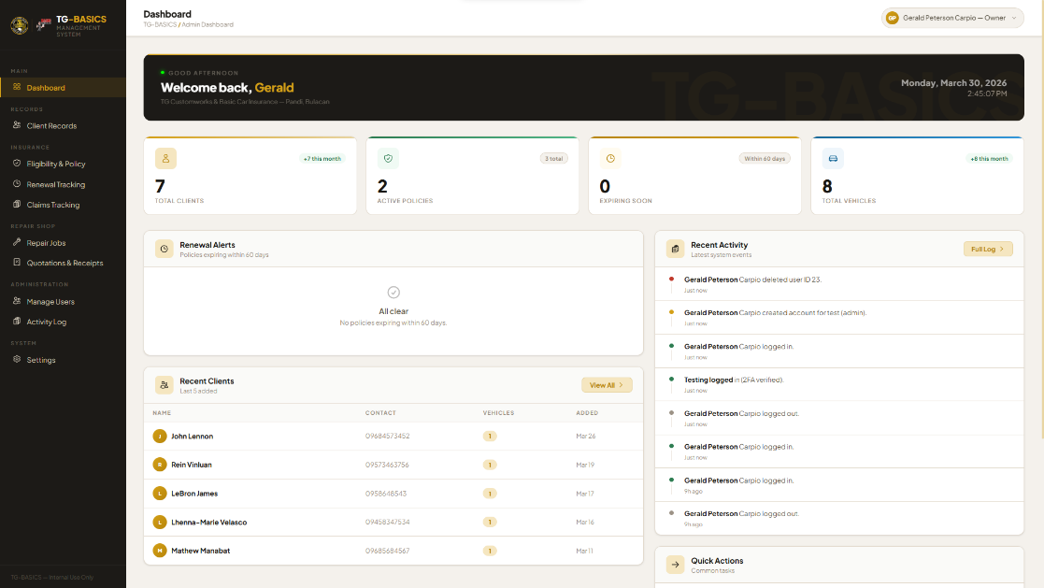
The Super Admin (Owner) has full access to all modules available to the admin, with the additional ability to manage system user accounts.

Figure 1.1 TG-BASICS Admin Dashboard UI
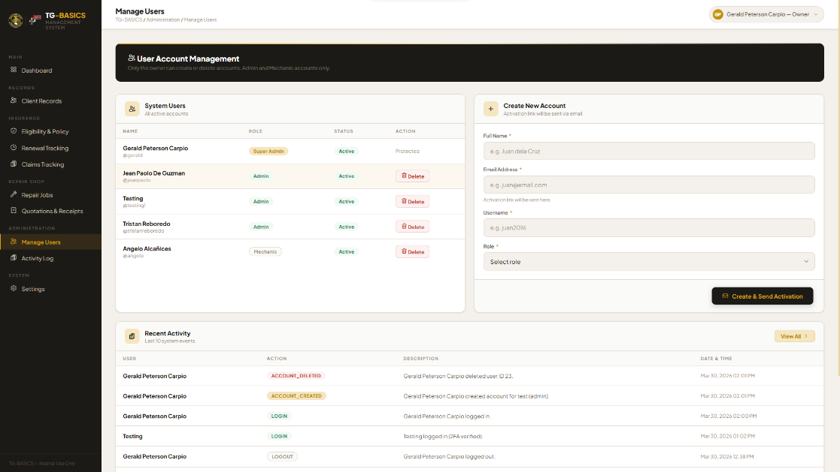
- User Account Management: Allows the Super Admin to create, edit, and deactivate system accounts for Admin and Mechanic users within the platform.

Figure 1.2 Super Admin User Account Management UI
For Admin
The Administrator (Internal Vice President) has full access to manage all business modules to ensure operational consistency.
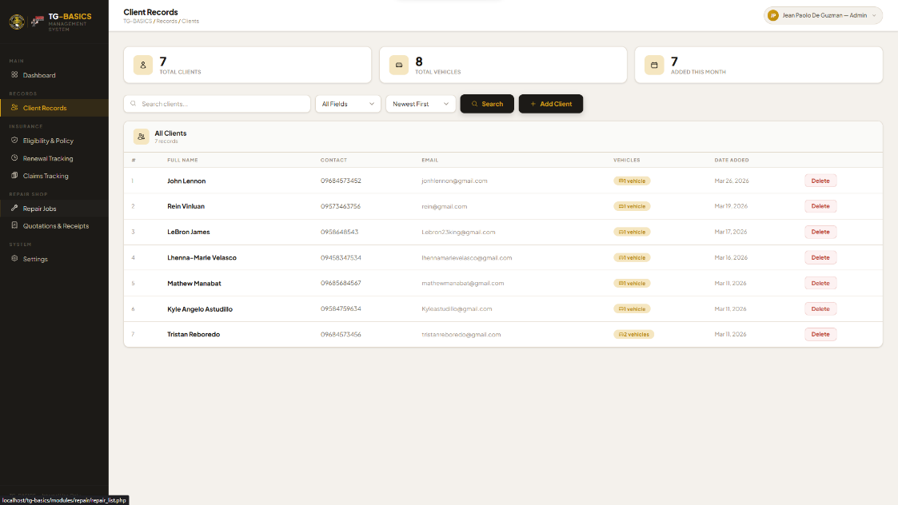
- Client and Vehicle Records Module: Provides a centralized database to store and search client profiles and vehicle details by name or plate number.

Figure 1.3 Admin Client Records UI
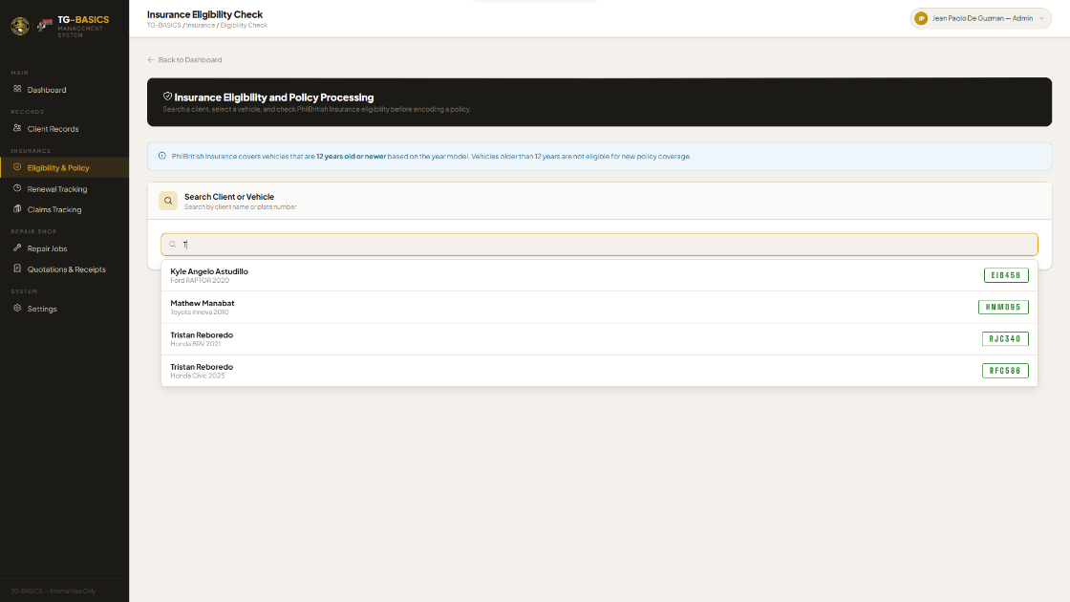
- Insurance Eligibility and Policy Processing Module: Automatically checks the 10-year age rule for vehicle eligibility and records comprehensive policy details.

Figure 1.4 Admin Insurance Eligibility UI

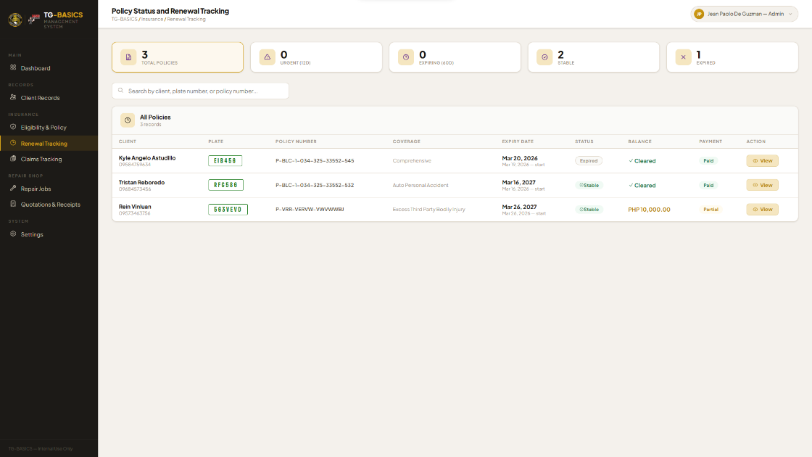
- Policy Status and Renewal Tracker: Features a color-coded expiry dashboard to monitor outstanding balances and identify policies nearing renewal.

Figure 1.5 Admin Policy Status and Renewal Tracker UI

- Claims Document Tracker: Logs and tracks the status of insurance claims and the completeness of required documents submitted to the head office. (Insert Figure: Figure 1.6 Admin Claims Document Tracker UI
- Repair Job Management Module: Allows the admin to oversee repair progress and access digital inspection results for every vehicle in the shop. (Insert Figure: Figure 1.7 Admin Repair Job Management UI
- Quotation and E-Receipt Generator: Uses a service price catalog to generate quotations and converts them into electronic receipts upon payment confirmation. Figure 1.8 Admin Quotation and E-Receipt Generator UI
For Mechanic
The Mechanic (Angelo Alcañices) has access to specific modules required for technical shop floor operations.
- Vehicle Inspection Module: A digital version of the External Car Condition Checklist used to document pre-existing vehicle damage.
Figure 1.9 Mechanic Vehicle Inspection UI
- Service Workflow Tracking: Allows the updating of real-time job status for per-panel repairs, basic wash overs, and full wash over services. (Insert Figure: Figure 1.10 Mechanic Service Workflow Tracking UI

Limitations
The limitations below are not weaknesses in the design. They are deliberate boundaries set based on what is realistic, what is within the researchers' control, and what the business actually needs right now.
- The system is built only for the Pandi, Bulacan branch of TG Customworks and Basic Car Insurance Services. It was not designed to be used by other branches or adapted for other automotive businesses.
- The system has no direct connection to PhilBritish Insurance. Everything that involves the head office, such as policy approvals, adjuster assignments, and official computations, still goes through the existing manual process outside of the system.
- The system does not handle actual payments. Cash, GCash, and bank transfers are still collected manually by the staff the way they always have been. What the system does is record that payment was received and generate an electronic receipt from the approved quotation.
- The system does not connect to Facebook Messenger or any other social media platform. The staff will continue to notify clients about renewals and other concerns through their existing channels.
- The remote insurance database managed by Maribel Ureta from Hong Kong is outside the scope of this system. Records maintained at the head office level will not be synchronized with TG-BASICS.
- The study only involved the staff members who were directly available and relevant to the processes covered by the system. Not all personnel of TG Customworks participated in the data gathering.
- Things like internet connectivity, hardware availability, changes in how the business operates over time, and long-term system maintenance are outside what the researchers can control and may affect how the system performs after it has been deployed.

